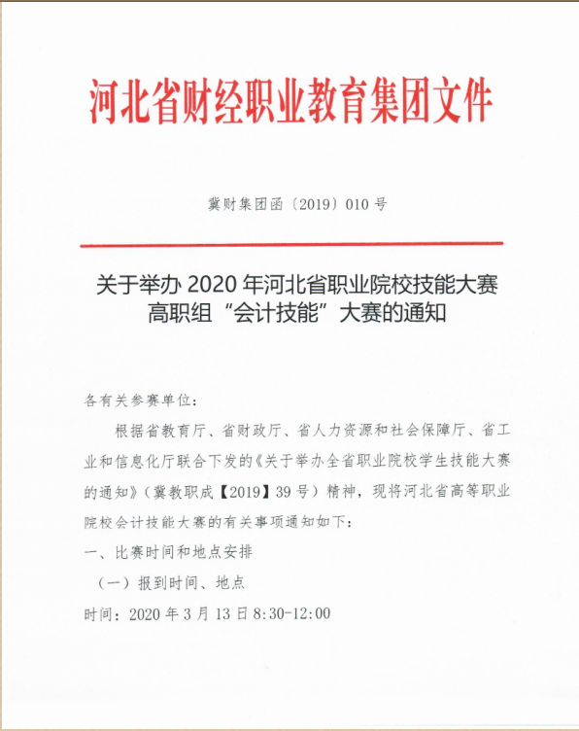

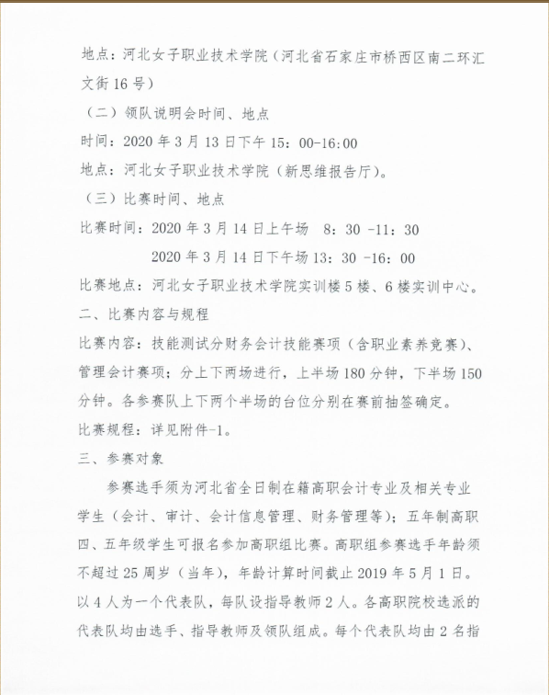

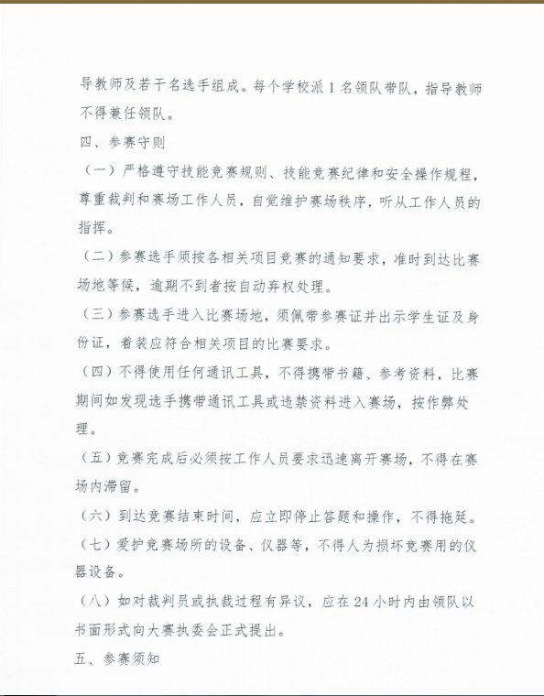

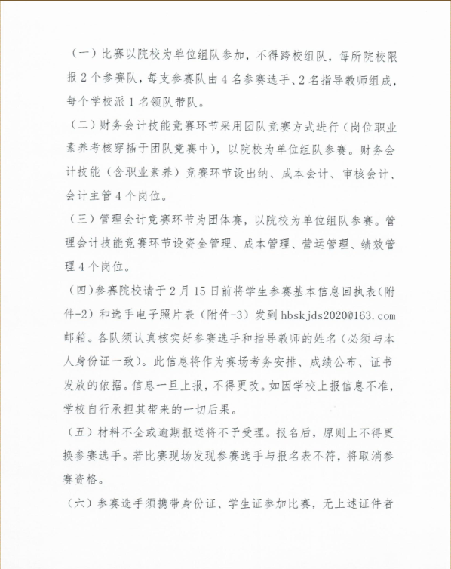

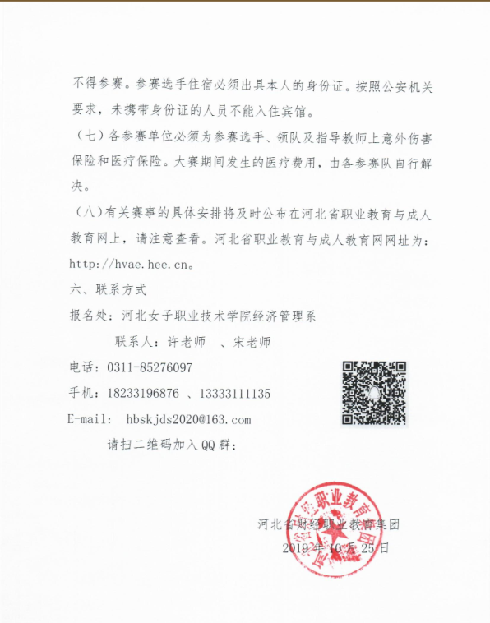

IMG_261[2020会计大赛(1).rar](http://hbszjs.hebtu.edu.cn/jnds/upload/ueditor/jnds/upload/ueditor/file/201911/1574934348341080059.rar" \o "2020会计大赛(1).rar)