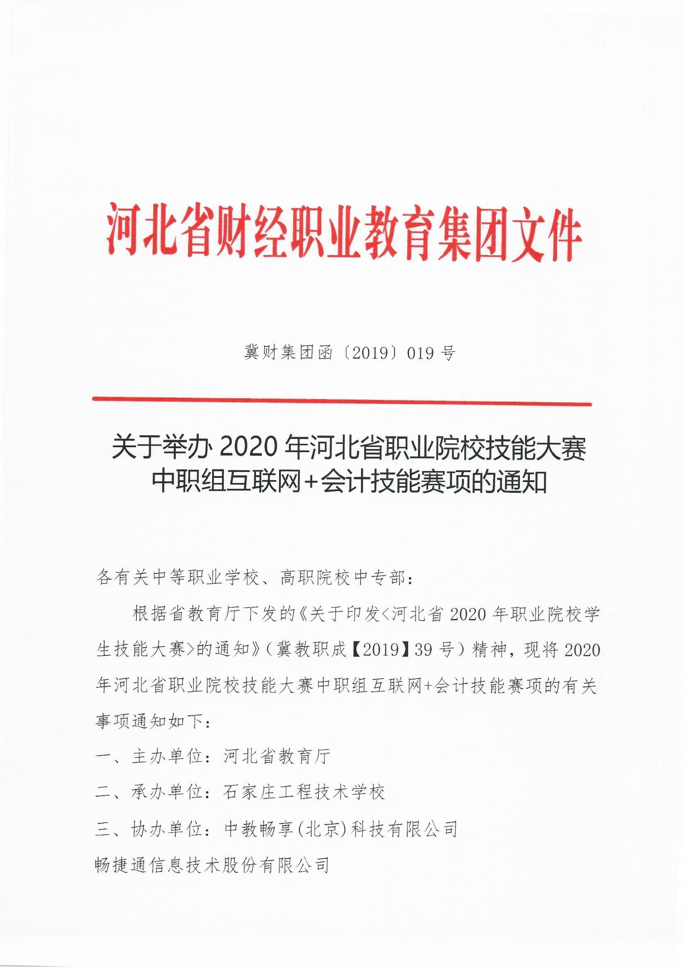

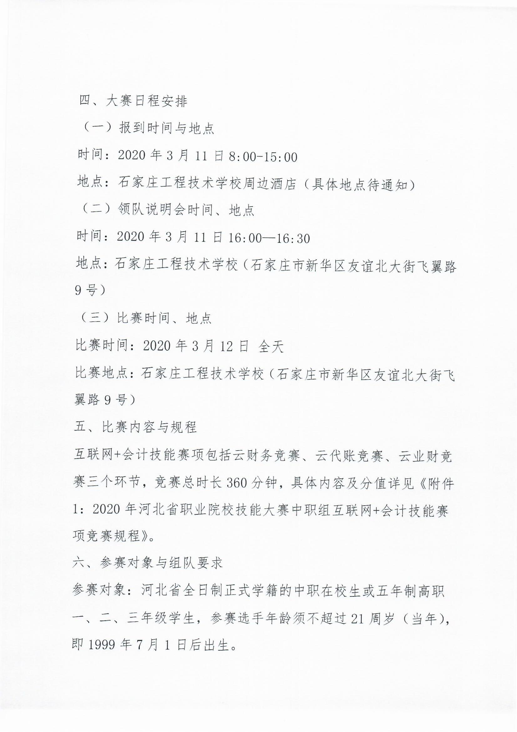

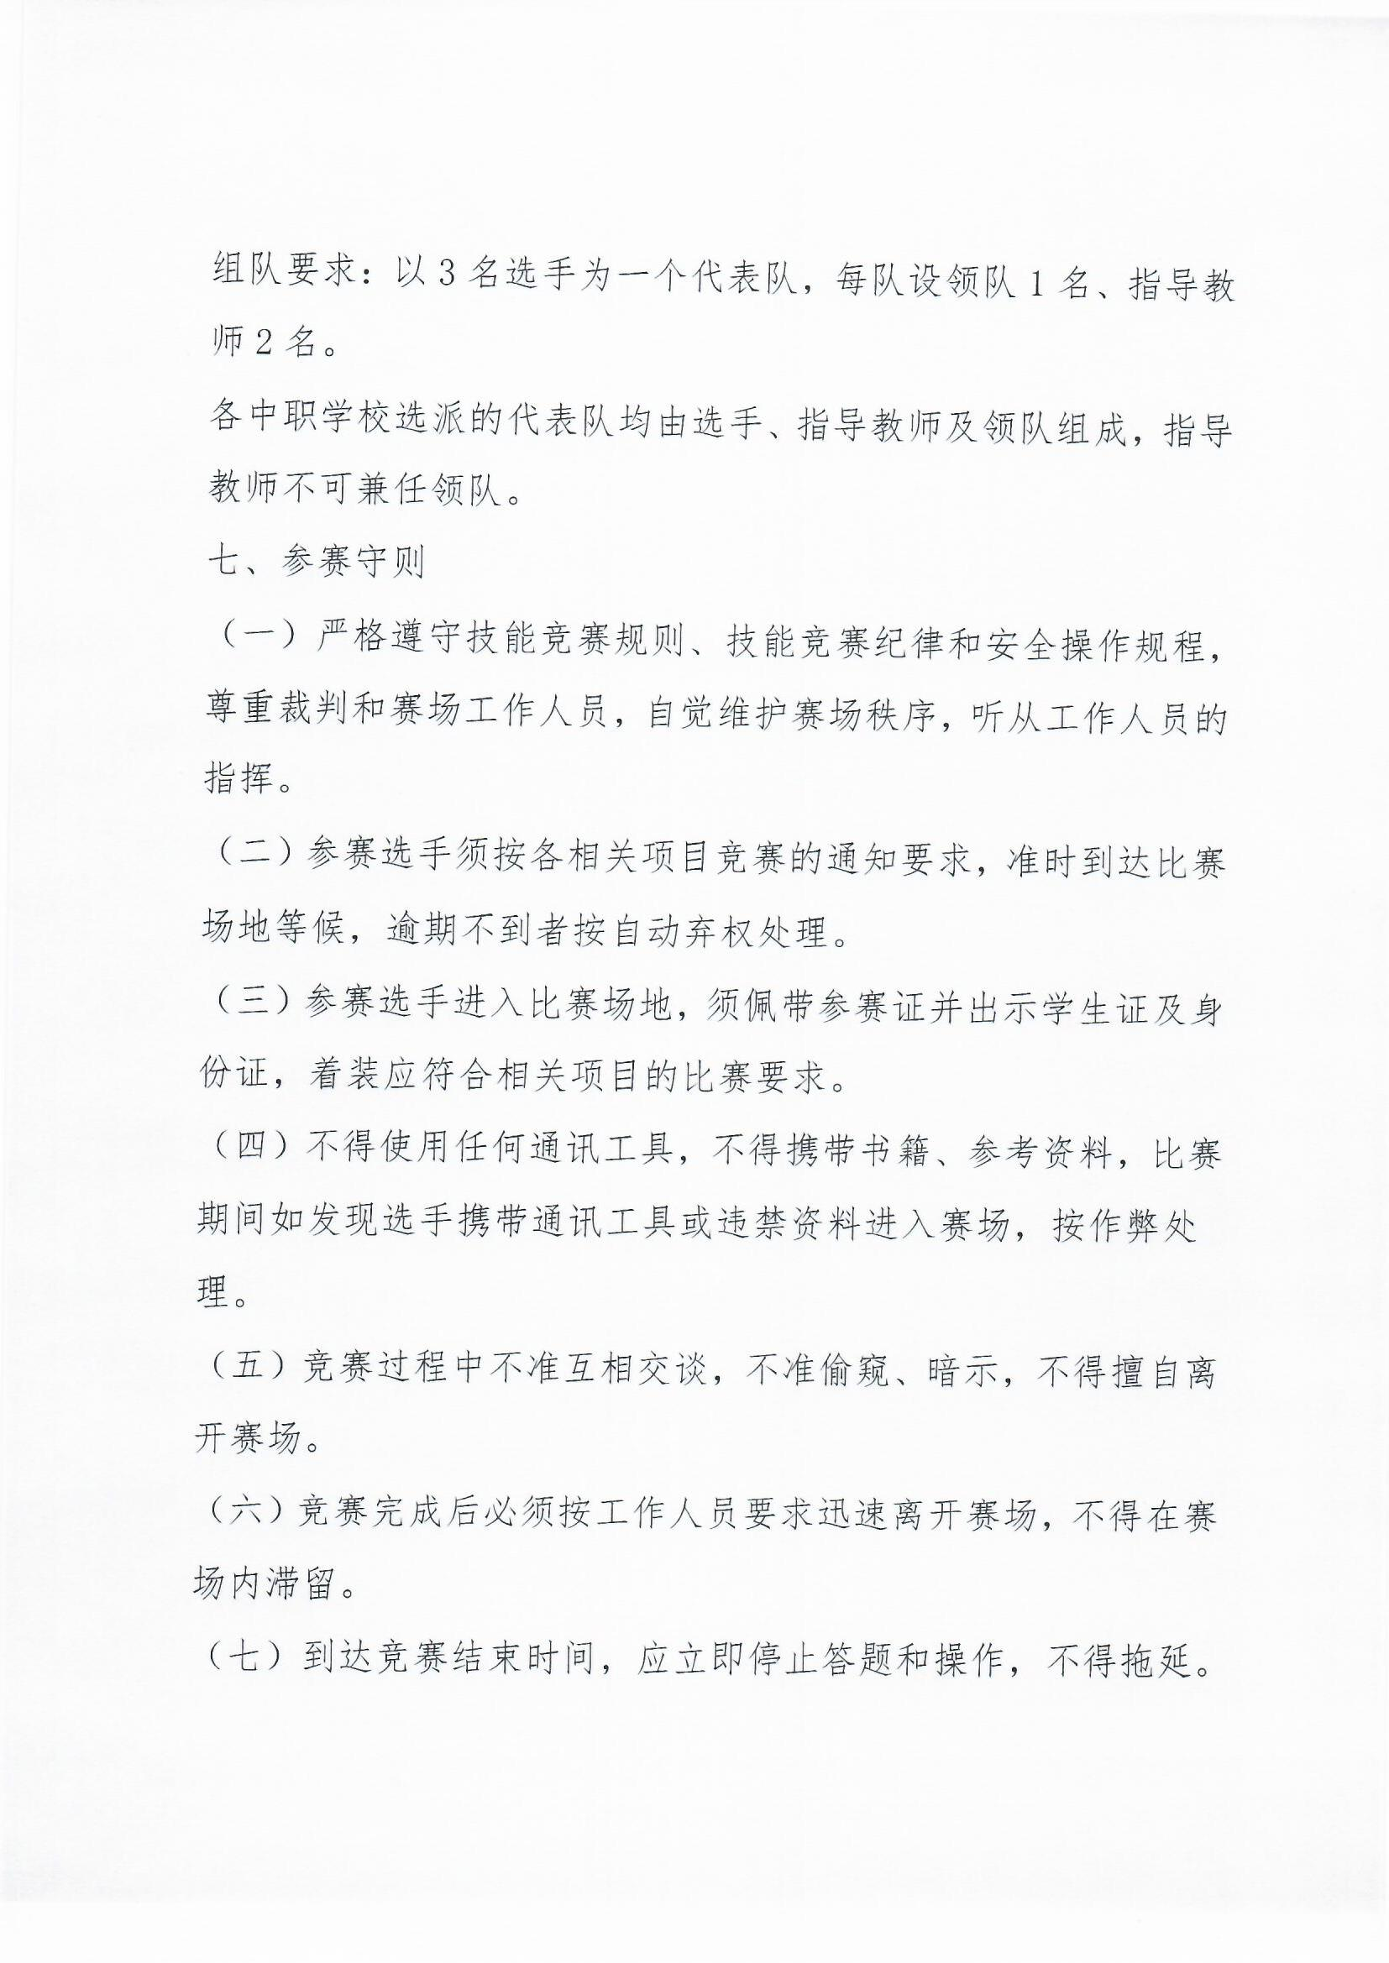

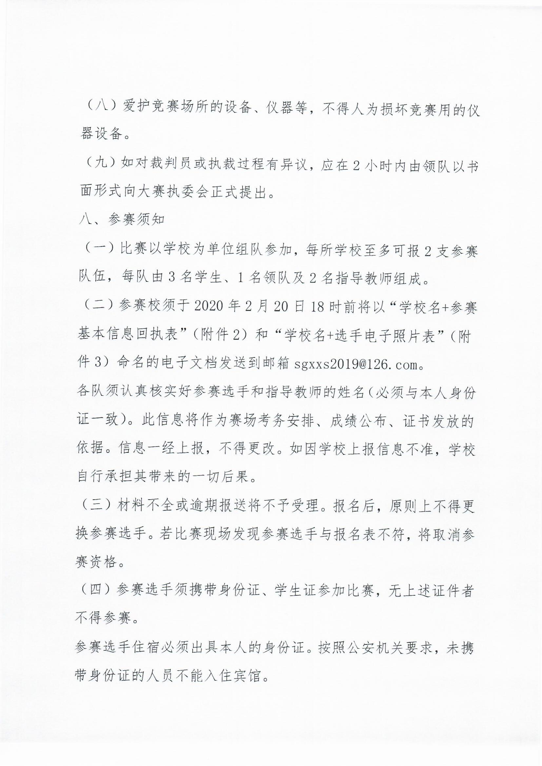

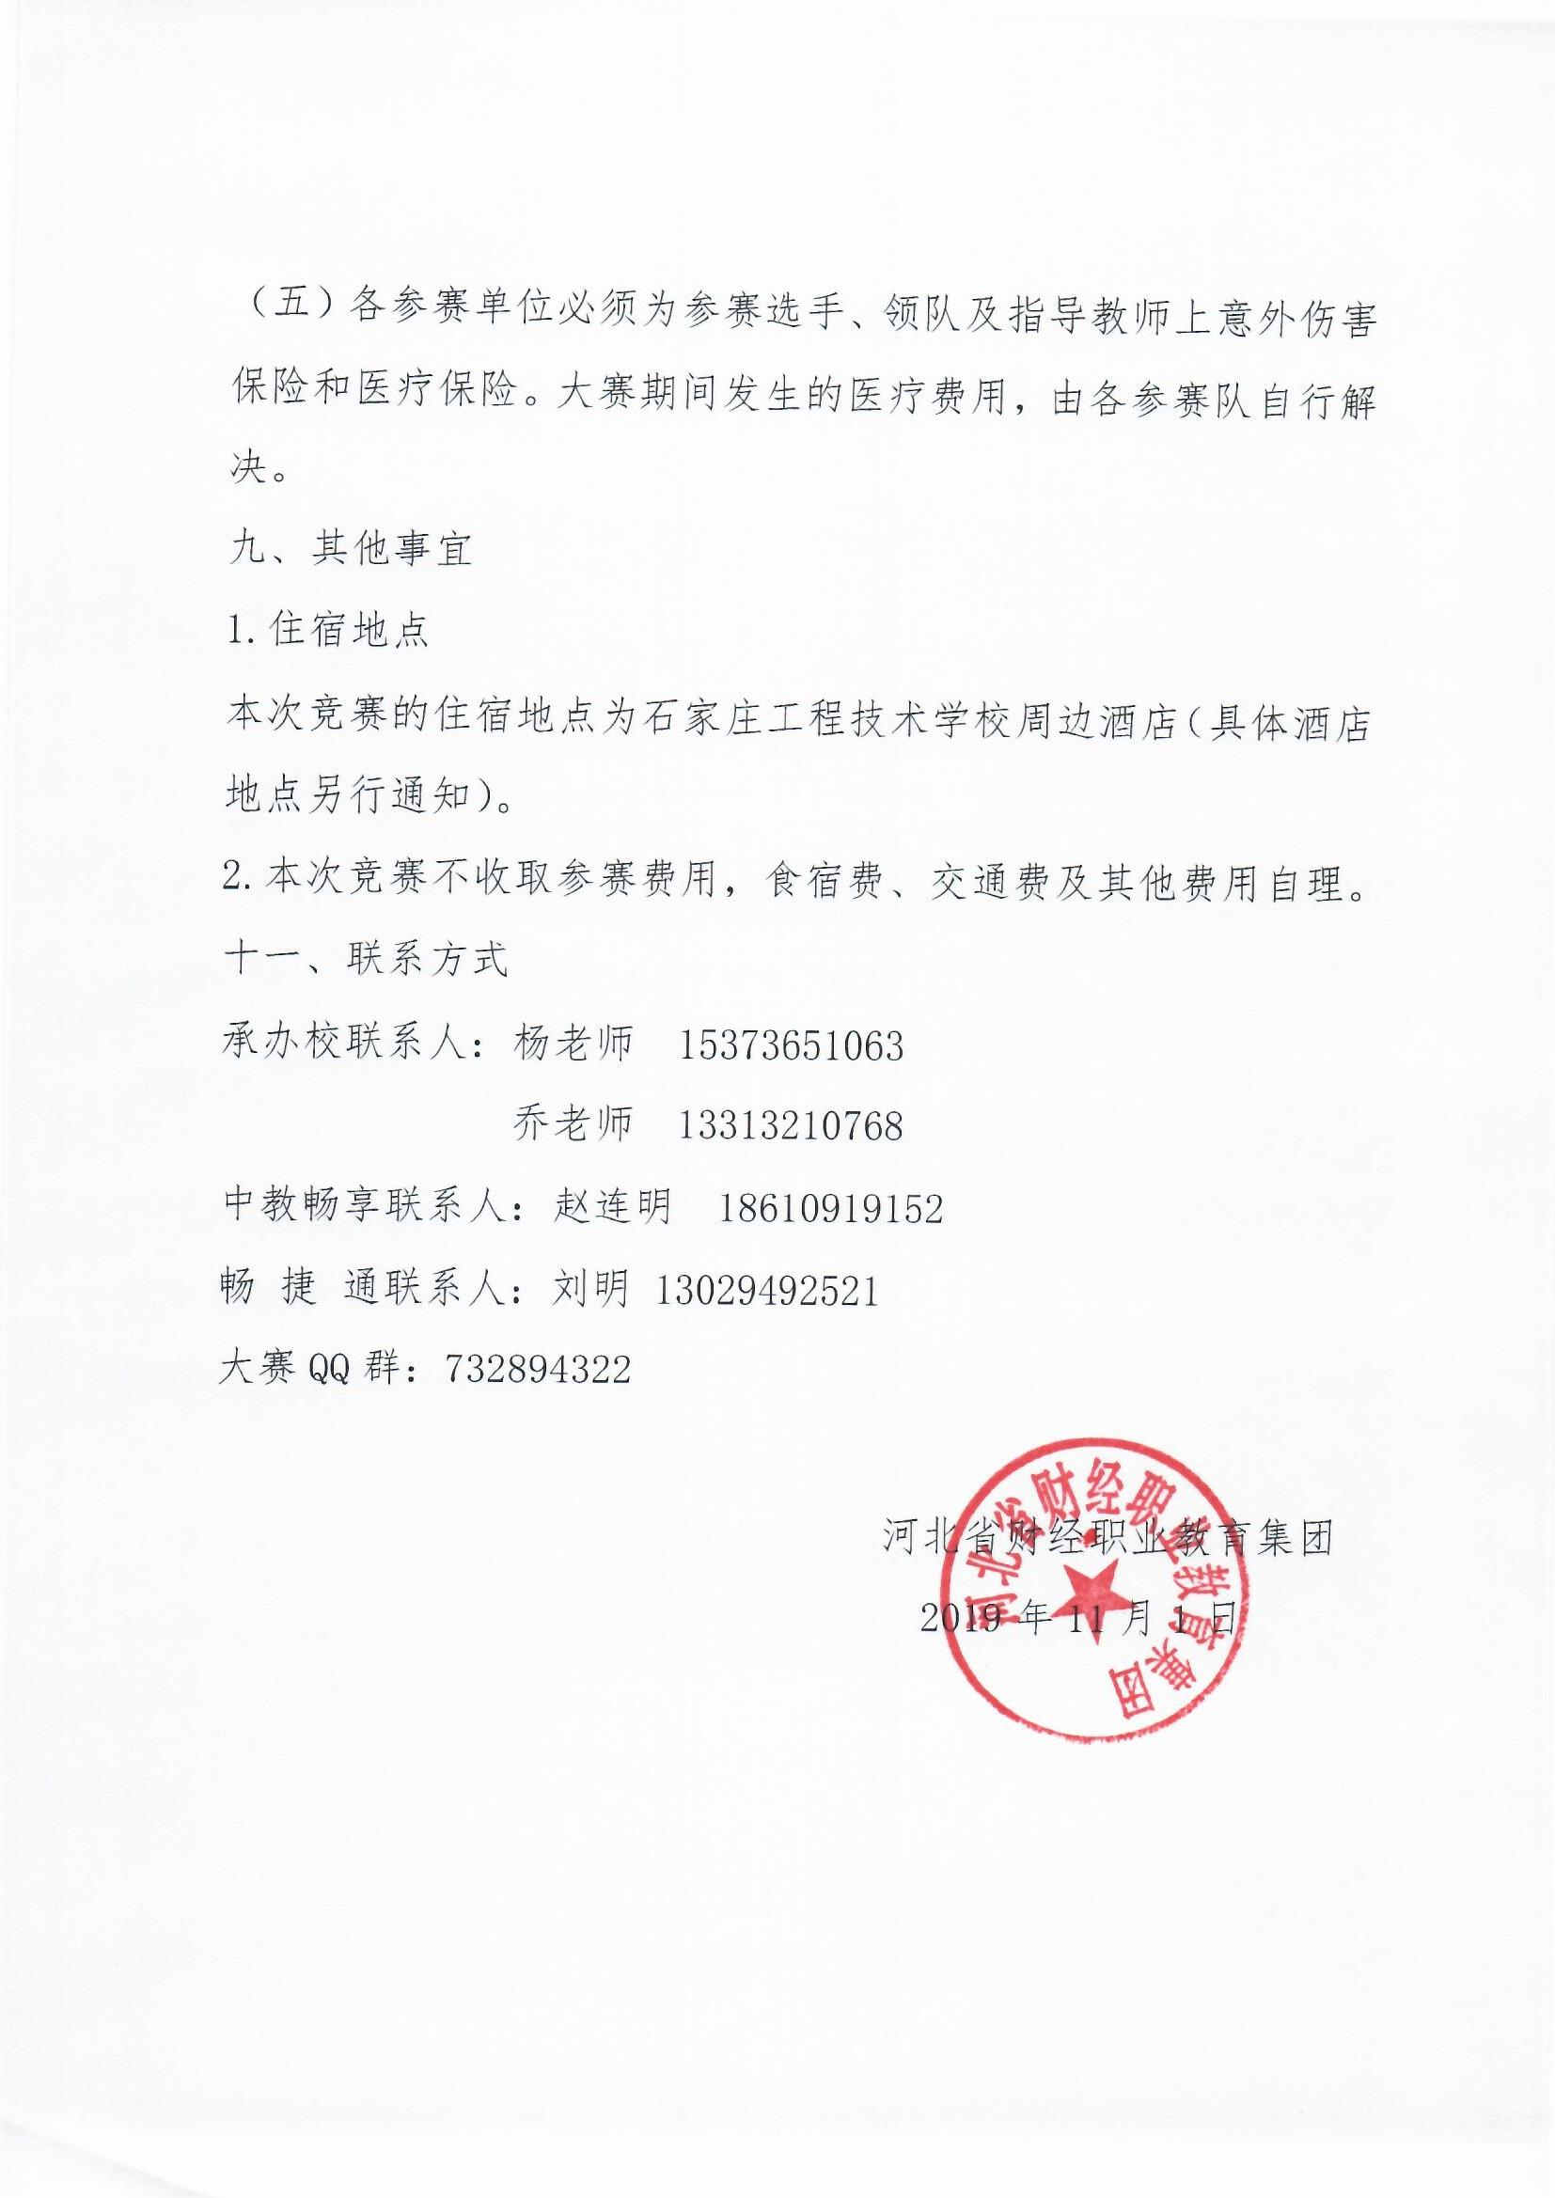

IMG_261[中职组互联网+会计技能大赛通知（修改）.zip](http://hbszjs.hebtu.edu.cn/jnds/upload/ueditor/jnds/upload/ueditor/file/201911/1575017824827039502.zip" \o "中职组互联网+会计技能大赛通知（修改）.zip)